Insertando imagen...

ACME-SF

G1.007

**Progress and analysis report S05-D02**

27 February 2024



# Cover

|  |  |
| --- | --- |
| **Repository:** <https://github.com/Pablo-Caballero-Maria/Acme-One-24.1.0-C1.07> | |
| **Student #1**  **ID:** 31878881F  **UVUS:**  pabcabmar3  **Name:** Caballero María, Pablo **Roles:** manager, developer | **Student #2**  **ID Number:**49034820Q  **UVUS:** mararnmon  **Name:** Arnáiz Montero, Marco Antonio  **Roles:** developer, operator |
| **Student #3**  **ID Number:** 77865211E  **UVUS:**  alfalolan  **Name:** Alonso Lanzarán, Alfonso Luis  **Roles:** developer, tester | **Student #4**  **ID Number:** 53932912M  **UVUS:** albsanmim  **Name:** Sánchez Mimbrero, Alberto  **Roles:** developer |
| **Student #5**  **ID Number:** 48123111G  **UVUS:** juagarcar4  **Name:** Garcia Carballo, Juan  **Roles:** developer , analyst |  |

# Table of contents

Executive summary 3

Revision table 3

Introduction 3

Contents 4

Conclusions 6

Bibliography 6

# Executive summary

A pivotal advancement in this phase has been the creation of the necessary entities that form the backbone of the project’s architecture. Furthermore, these newly created entities were subjected to "informal testing," a process that allowed for an early evaluation of their functionality and interoperability within the project's ecosystem.

Moreover, the team has invested time in analyzing the WIS requirements and diligently completing the required documentation, ensuring that all project activities are well-documented and aligned with the project’s objectives. This initial phase of the project, with its focus on setting up, creating essential entities, and conducting informal testing, has been instrumental in laying a solid foundation for the ACME-SF project.

# Revision table

|  |  |  |
| --- | --- | --- |
| Number | Date | Description |
| 1.0 | 27/02/2024 | Creation of the Document. Create a table of tasks assigned in this sprint, establish a budget, and write the introduction. |
| 1.1 | 07/03/2024 | Write the executive summary and conclusion, include screenshots of the project development, establish the progress record and real cost. |

# Introduction

The aim of this document is to deliver a comprehensive planning and progress report for the specific delivery of the project "ACME-SF" within the course "Design and Testing 2". This document is organized into two main chapters: planning and progress.

In the planning section, we detail the requirements set for this delivery, task assignments, roles of team members, planned time, actual time spent, and initial budget estimation. This methodical approach ensures that all facets of the project are meticulously outlined and allocated, fostering a clear vision for the way forward and setting realistic expectations for both the team and stakeholders involved.

Meanwhile, the progress chapter assesses the performance of the assignees, addressing conflicts that have arisen, and comparing the actual cost against prior budget estimations. This analysis not only reflects the team's commitment and efforts to meet the project's goals but also provides a critical and constructive view on areas for improvement, as well as the risk mitigation strategies implemented to ensure the successful achievement of the "ACME-SF" project objectives.

# Contents

* Planning
  + Task assigned this delivery:

|  |  |  |  |  |  |
| --- | --- | --- | --- | --- | --- |
| Title | Assignees | Priority | Estimate | Size | Role |
| Task S05-007/M: Produce an analysis report | JuanGarciaCarballo | P1 | 60 | M | developer |
| Task S05-001/I: Create "Code audit" entity | JuanGarciaCarballo | P0 | 60 | M | developer |
| Task S05-002/I: Create "Audit record" entity | JuanGarciaCarballo | P0 | 60 | M | developer |
| Task S05-005/I: Create "Auditor" role | JuanGarciaCarballo | P1 | 60 | M | developer |
| Task S05-005/T: Test "Code audit" entity | JuanGarciaCarballo | P0 | 60 | S | developer |
| Task S05-006/T: Test "Audit record" entity | JuanGarciaCarballo | P0 | 60 | S | developer |
| Task S05-008/M: Produce a UML domain model. | JuanGarciaCarballo | P1 | 60 | S | analyst |
| Task S05-004/T: Test "Auditor" entity | JuanGarciaCarballo | P0 | 60 | M | tester |
| Task S05-003/I: Create "Auditor dashboard" | JuanGarciaCarballo | P0 | 60 | M | developer |
| Task S05-006/M: Produce a planning and progress report | JuanGarciaCarballo | P1 | 60 | M | developer |
| Task G-018: Attend to class | JuanGarciaCarballo | P0 | 1440 | L | developer |

* + Different moments in the delivery

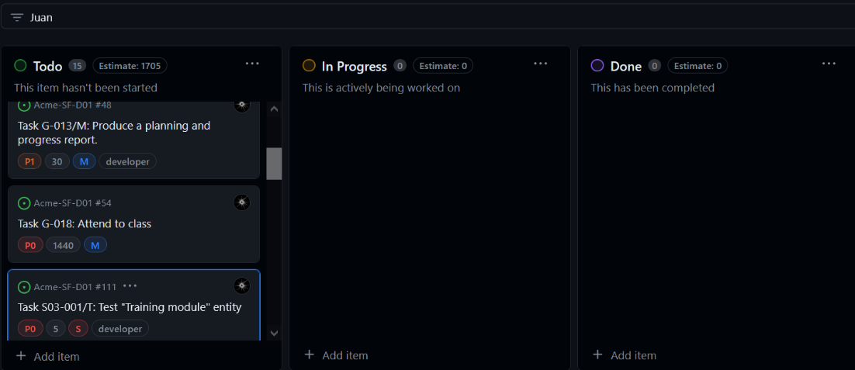

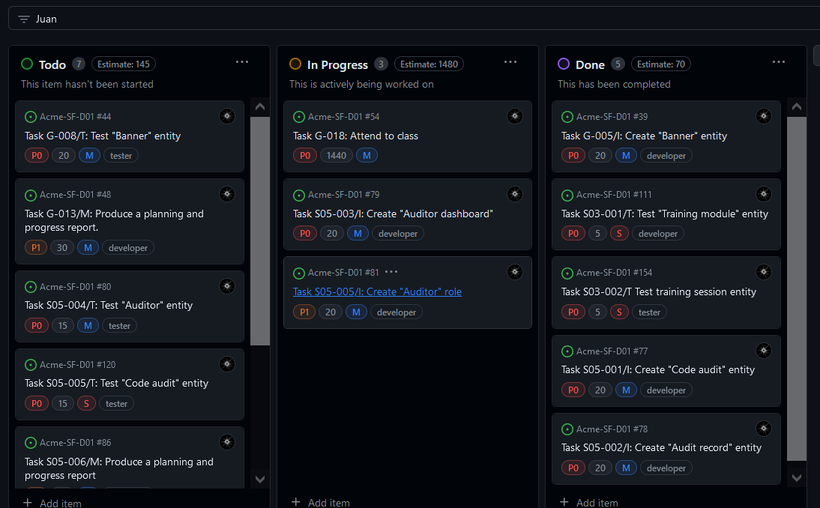

* + Budget

|  |  |  |  |  |
| --- | --- | --- | --- | --- |
| Title | Estimate | Role | € per hour | budget of the task |
| Task S05-007/M: Produce an analysis report | 60 | developer | 20 | 20 |
| Task S05-001/I: Create "Code audit" entity | 60 | developer | 20 | 20 |
| Task S05-002/I: Create "Audit record" entity | 60 | developer | 20 | 20 |
| Task S05-005/I: Create "Auditor" role | 60 | developer | 20 | 20 |
| Task S05-005/T: Test "Code audit" entity | 60 | developer | 20 | 20 |
| Task S05-006/T: Test "Audit record" entity | 60 | developer | 20 | 20 |
| Task S05-008/M: Produce a UML domain model. | 60 | analyst | 30 | 30 |
| Task S05-004/T: Test "Auditor" entity | 60 | developer | 20 | 20 |
| Task S05-003/I: Create "Auditor dashboard" | 60 | developer | 20 | 20 |
| Task S05-006/M: Produce a planning and progress report | 60 | developer | 20 | 20 |
| Task G-018: Attend to class | 1440 | developer | 20 | 480 |
|  |  |  | **TOTAL** | **690** |

Total cost of the equipment: 1000€

Total: 1690,00€

With a lineal amortization in 3 years of 563,33€ per year.

* Progress
  + Progress Records

Juan Garcia Carballo Ratio:1, is the best value possible, because I have completed all the task assigned.

* + Conflicts

Intentionally blank

* + Real Cost

|  |  |  |  |  |
| --- | --- | --- | --- | --- |
| Title | Invested time | Role | € per hour | Budget of the task |
| Task S05-007/M: Produce an analysis report | 60 | developer | 20 | 20 |
| Task S05-001/I: Create "Code audit" entity | 60 | developer | 20 | 20 |
| Task S05-002/I: Create "Audit record" entity | 60 | developer | 20 | 20 |
| Task S05-005/I: Create "Auditor" role | 60 | developer | 20 | 20 |
| Task S05-005/T: Test "Code audit" entity | 60 | developer | 20 | 20 |
| Task S05-006/T: Test "Audit record" entity | 60 | developer | 20 | 20 |
| Task S05-008/M: Produce a UML domain model. | 60 | analyst | 30 | 30 |
| Task S05-004/T: Test "Auditor" entity | 60 | developer | 20 | 20 |
| Task S05-003/I: Create "Auditor dashboard" | 60 | developer | 20 | 20 |
| Task S05-006/M: Produce a planning and progress report | 60 | developer | 20 | 20 |
| Task G-018: Attend to class | 1440 | developer | 20 | 480 |
|  |  |  | **TOTAL** | **690** |

Total cost of the equipment: 1000€.

Total: 1690,00€.

With a lineal amortization in 3 years of 563,33€ per year.

# Conclusions

In conclusion, the ACME-SF project is progressing from its foundational stages with a focus on essential tasks such as the establishment of a repository, entity creation, and informal testing. Financially, the budget analysis indicates a remarkable alignment between the estimated and actual costs, both calculated at 122,666€. This precise budgetary alignment is a testament to the team's effective financial management and planning acumen.

The congruence between budget and expenses not only exemplifies the project's financial diligence but also sets a promising stage for the forthcoming stages of development. With the financial aspect firmly in control, the project is poised for continued success

# Bibliography

Intentionally Blank